**MSA 6600 – Project Management – Project Milestone 3**

**Case Study: Catskill Family Practice**

Located in the foothills of the idyllic Catskill mountain ranges in southeastern New York State, Catskill Family Practice (CFP) has been providing medical care to families in the region since 1990. Their services include routine and preventive health care, fever and infections, respiratory problems, injuries, women’s health, birth control and pregnancy, pediatric care for babies and children, immunizations and well-child care, sports medicine including physicals, heart, skin, intestinal, urinary, muscle and bone problems, alcohol and drug dependency, and nutrition counseling. Established by Dr. Rip Van Winkle, CFP currently employs five physicians specializing in family / internal medicine, ten registered nurses, and six administrative staff. Dr. Winkle currently does not treat patients but oversees the administrative side of the practice.

With a patient base of over 15000, CFP was one of the leading family practitioners in the area; however, in recent years, new patient enrolment had dropped and existing patients were moving to newer healthcare facilities in the region. These newer facilities utilized state-of-the-art technologies, including electronic health records (EHRs) to manage patient care[1]. Dr. Winkle had eschewed technology his entire career and had been reluctant to utilize technology for patient care at CFP. They still relied on paper-based charts and records and the most they would use technology was in the form of electronic spreadsheets. However, declining patient numbers and the Patient Protection and Affordable Care Act[2] had put a lot of pressure on Dr. Winkle to rethink his stand on technology. In addition, the physicians and nurses at CFP had indicated their frustration at being so behind the technology curve in comparison to their competitors and felt they were missing valuable tools that had become essential for their professional careers. Their dwindling practice had affected their incomes and they conveyed to Dr. Winkle that CFP had to change with the times, and that they needed to invest in technology, specifically an EHR software. They impressed on him the advantages of an EHR[3]. In addition, a new community college had opened in the region, and was projected to bring in close to 20,000 new students to the area over the next few years. This would be a lucrative opportunity to expand their patient base, however to enroll this younger technology-savvy population, they would need to invest in new technologies. Given these circumstances, Dr. Winkle decided to consider an EHR implementation at CFP.

Dr. Winkle consulted with his colleagues as to the best way forward. Their competitors had gone in for off-the-shelf, packaged, vendor-provided EHR products[4][5]; however, there had been recent news reports that indicated usability issues with such products[6][7]. They were also concerned that an off-the-shelf software would disrupt established workflow processes and impose new work routines that might have a steep learning curve, which could negatively affect personnel morale, productivity and performance. Hence, Dr. Winkle took the decision to go in for a custom-built EHR software that would digitize existing workflow processes and thereby facilitate a seamless transition to the digital world with minimal usability issues. The proposed EHR should involve the implementation of a web portal with a back-end database that can be accessed by CFP personnel and patients. Dr. Winkle has approached Black Swamp Technology Consultants (BSTC) as their technology implementation partner for this project.

You are a project manager (PM) at BSTC and have been assigned to prepare a business case for the CFP project. BSTC has accorded maximum priority for this project as it is their first foray into the booming Health Information Technology (HIT) sector. Successfully implementation of this project could translate into other lucrative opportunities for BSTC. Hence, BSTC has given you a free hand in implementing the project. The core business model of BSTC consists of executing IT projects for client organizations (such as CFP) by deploying skilled human resources at the client site or at internal development centers. Projects may need personnel possessing a range of technical skills, and in some cases, capable of performing managerial roles. Technical skills may include expertise, experience and/or certification across programming languages, operating systems, software packages and hardware platforms, and managerial roles can include team leadership, systems administration, and project management.

As project manager, you first conduct preliminary interviews to solicit user requirements and translate them to product specifications. You quickly realize that while CFP was interested in having an EHR, none there had actually worked with an EHR and their knowledge was mainly based on conversations with colleagues working at other healthcare facilities that already had implemented EHRs and like technologies. However, most of them wanted what was considered “standard” for EHRs plus additions and modifications relevant to workflows that would be unique to CFP. Based on the Health Level Seven (HL7) International standards[8] [9] as enunciated by the American Academy of Family Physicians[10] and in consultation with CFP personnel, you have shortlisted the following functionalities for the EHR[11]:

* Identify and maintain a patient record
* Manage patient demographics
* Manage problem lists
* Manage medication lists
* Manage patient history
* Manage clinical documents and notes
* Capture external clinical documents
* Present care plans, guidelines, and protocols
* Manage guidelines, protocols and patient-specific care plans
* Generate and record patient-specific instructions

Your preliminary analysis indicates the following gains (or benefits) from the project in the first year following implementation (Year 1) through improved patient retention, attracting new patients, and improved operational efficiencies would amount to $1,450,000.00.

The EHR is expected to have a useful life of 5 years with the gains/benefits from Year 1 projected to increase by 10% every year over the next 4 years. Initial investment (in Year 0) is estimated to be $500,000 for hardware installation and related infrastructure, $500,000 for employee training, and $2,000,000 for software development labor costs. Contingency reserves are pegged at $500,000 (these is money budgeted for meeting unexpected circumstances).

The operational costs for the useful life of the project (i.e. 5 years) is estimated at $150,000/year for hardware maintenance, $100,000 /year for software updates, and $150,000 / year for operational labor.

As PM, you anticipate considerable technical challenges for the implementation. While the hardware installation is expected to proceed smoothly, the relative inexperience of BSTC software developers in the HIT segment had the potential to slow down the software development. Hence, you plan to include the best software developers from BSTC into the project team. In addition, if deemed necessary, you plan to utilize external consultants to support the BSTC team in software development activities (contingency reserves may be used for this purpose). The project team is expected to have 10-15 personnel composed mainly of software programmers. Extensive involvement of CFP personnel would be required for successful completion of the project, however there is concern regarding the actual amount of time physicians and nurses might be able to devote to the implementation given their workload.

The personnel at CFP include five practicing physicians: Drs. Ackerman, King, Koehler, Jones, and Moore. Dr. Winkle does not practice but takes care of the overall administration of CFP – he is very supportive of the project. Dr. Ackerman is the senior most practicing physician at CFP and widely viewed as the best physician from among the five – however you sense that he is not a staunch supporter of the EHR project. His opinions carry great weight with Dr. Winkle, and you feel that if he opposes the project, the implementation may not proceed smoothly. Drs. King and Koehler are close friends and viewed as moving in sync with one another, and they appear neutral towards the project – you feel that by interacting with them, you could convince them into actively supporting the project. Also, they appear very popular and influential with the nursing staff and you feel their views on the project could strongly influence the nursing staff. Drs. Jones and Moore are the junior most doctors and appear very supportive of the project, however they do not appear to wield much influence within CFP. The nursing staff of ten and administrative staff of six seem to have considerable apprehension regarding the project. They feel that the implementation will impose a steep learning curve on them given the predicted changes to operational workflows. While the physician’s compensation was tied to CFP profits, other employees were paid a fixed annual salary. Hence, they feared that they would end up shouldering the burden of the implementation without any related benefits.

Your business case for the project has been approved by Dr. Winkle and he has decided to proceed with the project. The total budget for the project would be $3,500,000 [$500,000 for hardware installation and related infrastructure, $500,000 for employee training, $2,000,000 for software development labor costs, and contingency reserves of $500,000]. The project would need to be completed in 1 year. It would need to have the following functionalities:

* Identify and maintain a patient record
* Manage patient demographics
* Manage problem lists
* Manage medication lists
* Manage patient history
* Manage clinical documents and notes
* Capture external clinical documents
* Present care plans, guidelines, and protocols
* Manage guidelines, protocols, and patient-specific care plans
* Generate and record patient-specific instructions

From a technical perspective, these functionalities would be operationalized using a MS SQL Server database having a web-based interface.

You have reached an agreement with Dr. Winkle regarding the success criteria for the project: the project would be considered a success if it meets the scope, time, and cost parameters. Your next step as project manager is to put together the project team. Project teams need personnel possessing a range of technical skills, and in some cases, capable of performing managerial roles. Technical skills may include expertise, experience and/or certification across programming languages, operating systems, software packages and hardware platforms, and managerial roles can include team leadership, systems administration, and project management.

You have shortlisted the following individuals for different roles in your project team:

* Business System Analysts: Cauthon, Pitt, Cuomo

[*Business systems analysts (BSA) work with the business to understand their needs, but their specialty and focus is the business’ needs related to information technology*[12]*.* In the context of this project, they will work with the physicians, nurses, and administrative staff at CFP to determine the technical and functional specifications for the EHR software.]

* Programmer Analysts: Leakey, Morris, Fitzgerald

[*Programmer analysts (PA) design the software programs and databases for new systems. They are usually responsible for testing software to ensure there are no problems and debugging programs whenever problems arise*.[13] In the context of this project, they will receive input from the BSAs and do the actual design and development of the EHR software.]

* User Interaction Designer: Walden

[*User Interaction Designers (UID) are responsible for creating the look and feel of computer interfaces. Their primary goal is to maximize the potential of the human-computer interaction so the user can easily navigate and understand the software's functionality[14]*. In the context of this project, the UID will receive input from the BSAs and CFP employees to develop intuitive easy-to-use screen interfaces for physicians, nurses, administrative staff, and patients]

* CFP Employees: Koehler (Physician), Andrews (Nurse), Harris (Staff)

[CFP employees in the project team will include a physician, nurse, and administrative staff on a part-time basis for 10 hours/week. Their role is to provide an end-user perspective and continual feedback at all stages of the project. These employees have informed you that while they would try their best to devote 10 hours/week on the project, if they have additional workload (such as higher number of patients than normal in week), they may not able to spend that much time on the project]

The project charter and preliminary scope statement were reviewed by Dr. Winkle and the CFP employees involved in the implementation Koehler, Andrews, and Harris. They made several suggestions some of which were incorporated into the scope. After several iterations, the scope statement was finalized and approved.

Based on the finalized scope statement, the project charter and the business case, you (as project manager) in consultation with the team members has finalized the WBS. The time duration and sequencing of activities have been completed. Human resources have been allocated to each activity. The standard billing rate for each project member has been fixed as follows (Vendor costs are included in hardware installation costs):

|  |  |
| --- | --- |
| Resource Name | Std. Rate |
| PM | $125.00/hr |
| Cauthon | $100.00/hr |
| Pitt | $100.00/hr |
| Cuomo | $100.00/hr |
| Leakey | $120.00/hr |
| Morris | $120.00/hr |
| Fitzgerald | $110.00/hr |
| Walden | $120.00/hr |
| Vendor | $0.00/hr |

The details of the WBS, time duration and sequencing of activities, and allocation of human resources is shown in the figure in the following page.

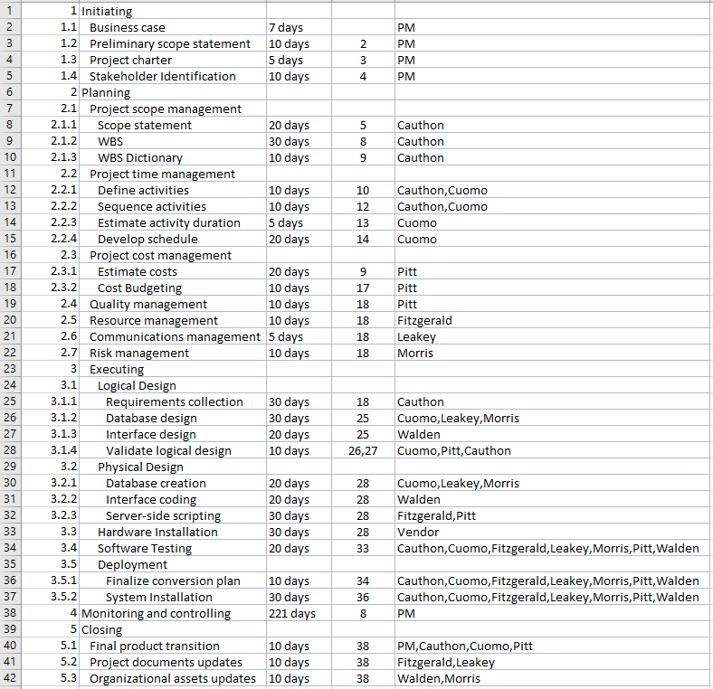

Activity serial number (assigned sequentially to every single activity)

WBS serial number (assigned based on activity level; 1, 2, 3, 4, 5 are assigned to the highest level – Initiating, planning, executing, monitoring and controlling, and closing. Within each of these activities, you have lower level activities; for example, within activity 2 (Planning), you have seven lower level activities; 2.1, 2.2, 2.3, 2.4, 2.5, 2.6, 2.7 corresponding to Project scope management, Project time management, Project cost management, Quality management, Resource management, Communications management, Risk management. Each of these can further have lower level activities; for example, activity 2.1 Project scope management has three lower level activities in 2.1.1, 2.1.2, 2.1.3.)

List of WBS Activities

Time duration of each activity

Predecessor activity serial number (predecessor to activity 4 (WBS serial number 1.3) Project Charter would be activity 3 – Preliminary scope statement)

Human resource allocated to activity (PM refers to project manager; activity 33 is hardware installation by the external supplier)

***Develop a Gantt Chart in MS Project reflecting the project details shown in the figure in the previous page. Include a Cost column to the right of the Resource column. Upload the MS Project file you have developed to Canvas.* (75 points)**

Steps:

* ***Please download your individual copy of MS Project 2016 into your PC based on the instructions shown in Canvas. Please work individually on your installed copy of MS Project 2016.***
* Review the video at [MS Project 2016 - Basics In 15 Minutes](https://www.youtube.com/watch?v=goX6N9RjGUs)
* Open a blank MS Project document
* Do not change any of the default settings – the Gantt chart will assume that the project commences on the day you are creating the Gantt chart – you need not change it
* Go to Format > select Outline Number (this will switch on WBS serial numbering)
* Enter all 42 tasks in the Task Name column (as you do this, the activity serial number will appear in the leftmost column from 1 to 42, and the WBS serial number will appear by the side of each task name sequentially from 1 to 42)
* Indent the activities into their appropriate levels, this will automatically generate the WBS serial numbers shown in the figure above, and all activities that have lower level activities will be shown in bold
* Enter the time duration for each activity in the Duration column – note that a time is given only for the activities at the lowest level (as you can see, MS project will sum these times to generate the time for higher level activities). A time-based horizontal bar will be generated for each activity in the Gantt chart to the right.
* Enter the predecessor activity serial number in the Predecessors column – the bars in the Gantt chart arrange themselves based on the sequence of activities
* Go to Task > Gantt Chart > select Resource Sheet
* Enter the resources for the project under Resource Name: PM, Cauthon, Pitt, Cuomo, Leakey, Morris, Fitzgerald, Vendor
* Assign the billing rate for each resource under Std. Rate
* Click on Gantt Chart to return to the Gantt Chart view
* Allocate human resources to each project activity
* Include a Cost column to the right of the Resource column
* View the Cost Overview report

Based on current estimates, the project would be completed in slightly over a year. Dr. Winkle is worried that the project might take longer than that and wants to know whether the project could be speeded up. You explain to him the concept of network diagrams and the critical path and how crashing could result in shortening the time required for project completion. However, Dr. Winkle wanted further clarification of network diagrams.

***Prepare a report for Dr. Winkle on network diagrams based on the sample network outlined below – the report should address the questions shown.* (75 points)**

|  |  |  |  |  |
| --- | --- | --- | --- | --- |
| **Activity** | **Time Estimate** | | | **Preceding Activity** |
|  | Optimistic (o) | Realistic (r) | Pessimistic (p) |  |
| A | 1 | 4 | 7 | - |
| B | 2 | 4 | 6 | A |
| C | 1 | 3 | 5 | B |
| D | 2 | 3 | 4 | B |
| E | 3 | 6 | 9 | B |
| F | 1 | 3 | 5 | C, E |
| G | 1 | 1 | 1 | B, C, E |
| H | 5 | 6 | 7 | D, F, G |
| I | 5 | 5 | 5 | H |

1. Develop the network diagram (include the diagram in the report)
2. Compute the slack time for each activity
3. Using the data from (b), identify the critical path and time of completion of the project

The following are the project team members available to you to allot to activities A to I and their recent performance evaluations:

|  |  |
| --- | --- |
| **Name** | **Performance Evaluation** |
| Neha | Excellent |
| Jake | Excellent |
| Dawn | Excellent |
| Todd | Good |
| Mary | Good |
| Nick | Good |
| Crystal | Fair |
| Joe | Fair |
| Andy | Fair |

1. Based on (a) and (b), assign one team member to each of the project activities. Explain your rationale.
2. The completion time for the project must be reduced further and for that purpose you have been provided with two new team members - Tweedledee and Tweedledum. With a performance rating of “Exceptional”, they are so exceptionally talented that when allotted to any of the project activities (A to I), the time needed to complete that activity gets reduced by half. Which activities (if any) should they be allotted to (after removing the person already allotted to that activity), to facilitate the maximum reduction in time for completion of the project? Explain your rationale for allocation.

* **Please review the Project Milestone Assignment Grading Rubric from the syllabus.**
* **This is an individual activity. The Turnitin software will be used to review the report – so please make sure you submit your individual work.**
* **Please upload your MS Project (.mpp) file and report to Canvas on or before 06/21/2020.**

1. <https://www.healthit.gov/topic/health-it-and-health-information-exchange-basics/what-are-electronic-health-records-ehrs>
2. <https://www.congress.gov/bill/111th-congress/house-bill/3590>
3. <https://www.healthit.gov/providers-professionals/faqs/what-are-advantages-electronic-health-records>
4. <http://www.curemd.com/top-ehr-vendors/#top_nine>
5. <https://www.softwareadvice.com/medical/electronic-medical-record-software-comparison/>
6. <https://www.aafp.org/news/practice-professional-issues/20170221directinteroperability.html>
7. <https://healthcarethinktank.org/health-it-usability-impacts-patient-safety-outcomes/>
8. <http://www.hl7.org/>
9. <http://www.hl7.org/implement/standards/>
10. <http://www.aafp.org/home.html>
11. <http://www.aafp.org/practice-management/health-it/product/features-functions.html>
12. <https://www.iiba.org/Careers/Careers/understanding-the-s-in-business-systems-analysis.aspx>
13. <http://study.com/articles/Programmer_Analyst_Job_Description_Duties_and_Requirements.html>
14. <http://study.com/articles/User-Experience_Designer_Job_Description_and_Requirements.html>